**NAAN MUTHALVAN**

**DIGITAL MARKETING PROJECT**

HOW TO CREATE A GOOGLE ADDS CAMPAIGN FOR YOUR BRAND

**PROCEDURE OF OUR PROJECT**

**STEP 1:**

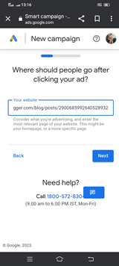

**STEP 2:**

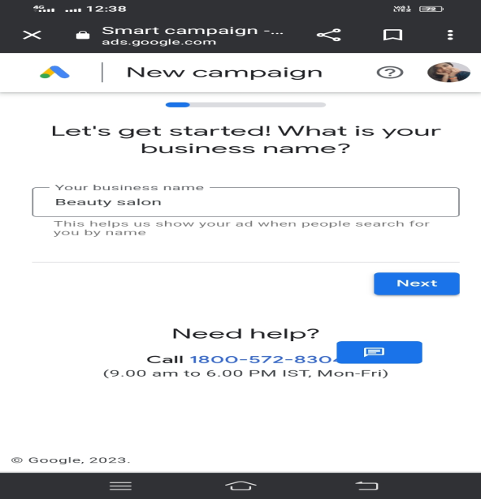

**STEP 3:**

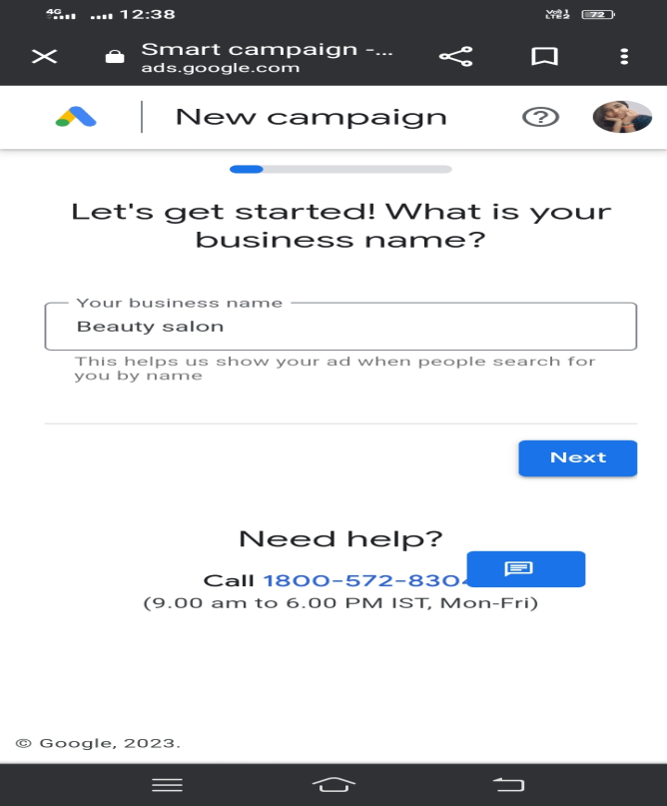

**STEP 4:**

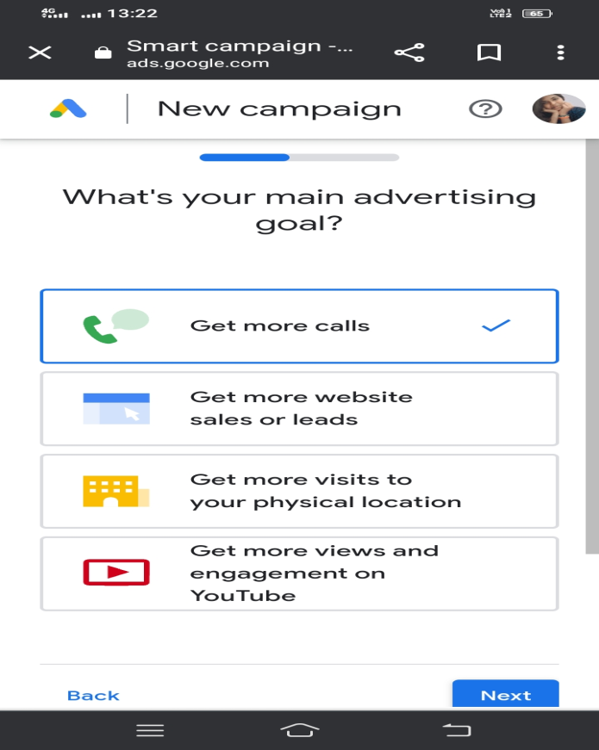

**STEP 5:**

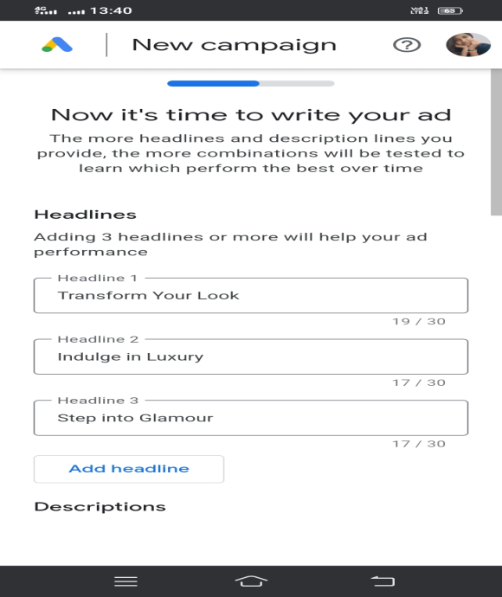

**STEP 6:**

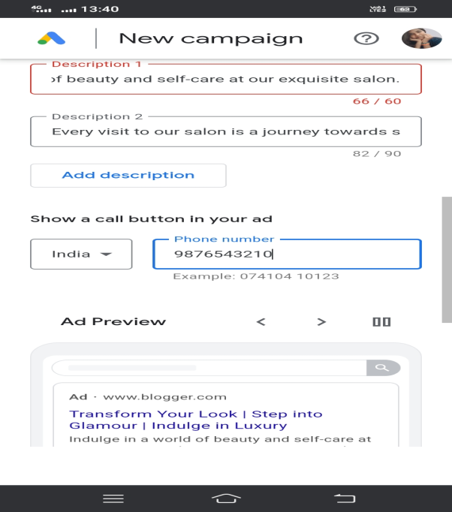

**STEP 7:**

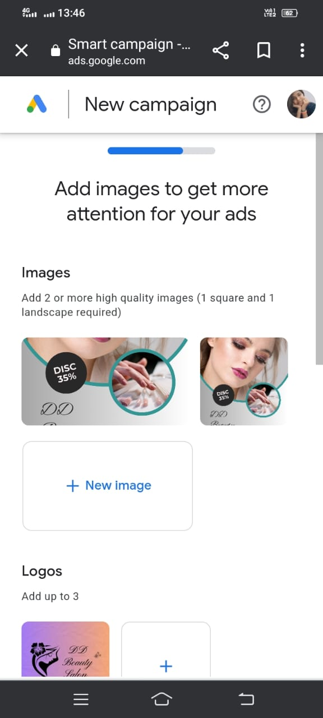

**STEP 8:**

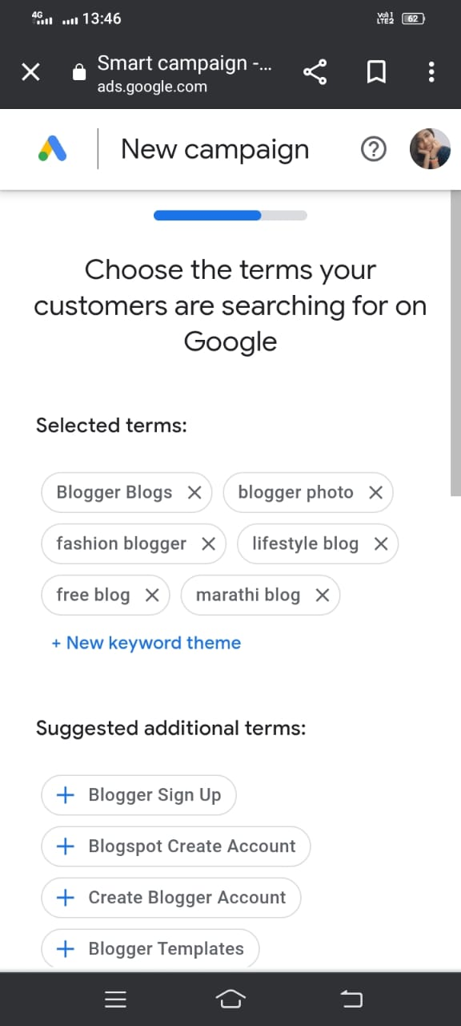

**STEP 9:**

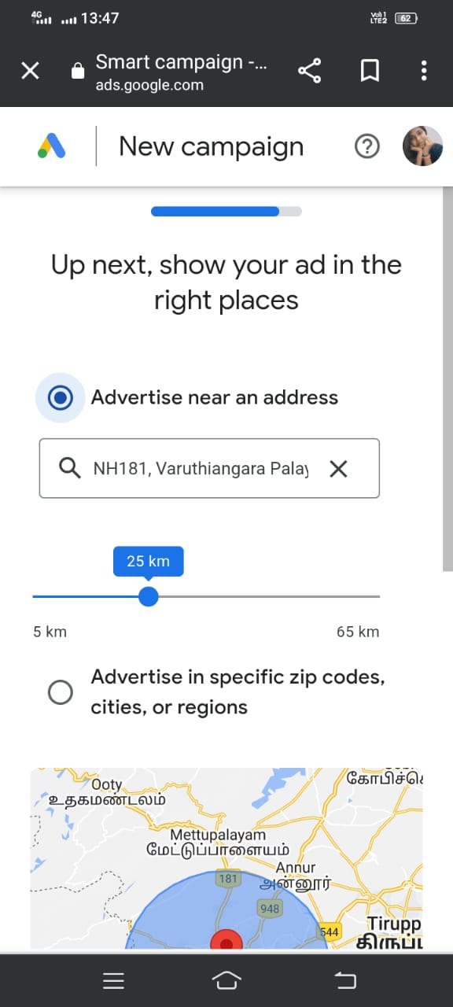

**STEP 10:**

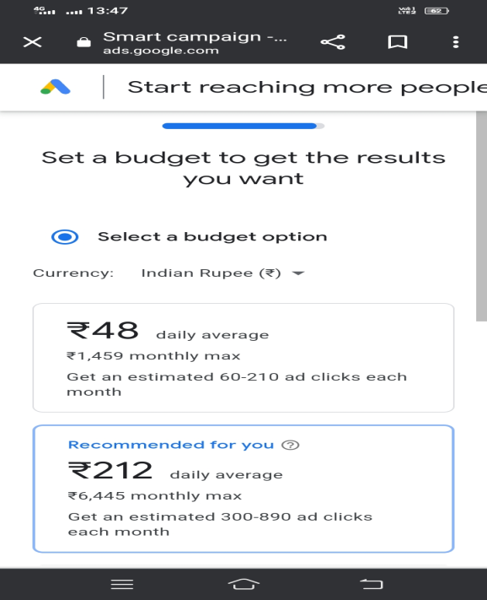

**STEP 11:**

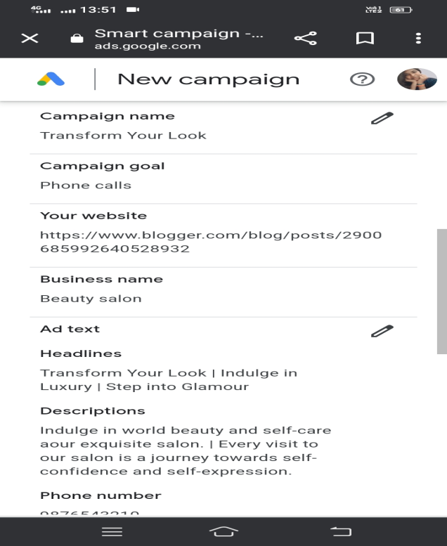

**STEP 12:**

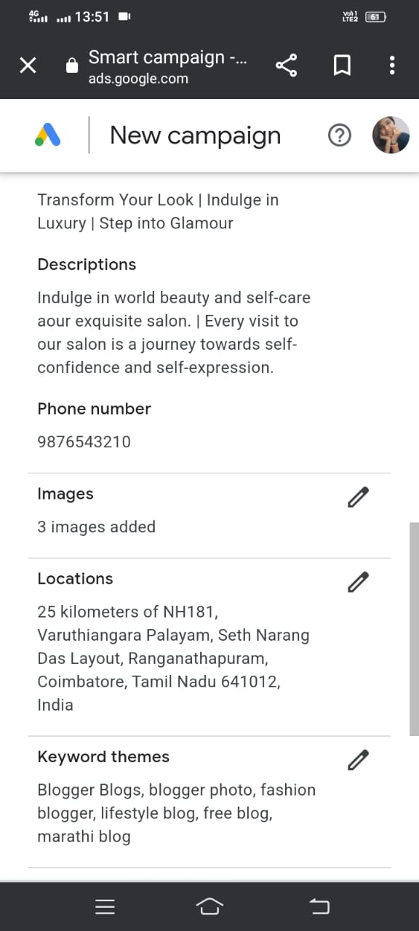

**STEP 13:**

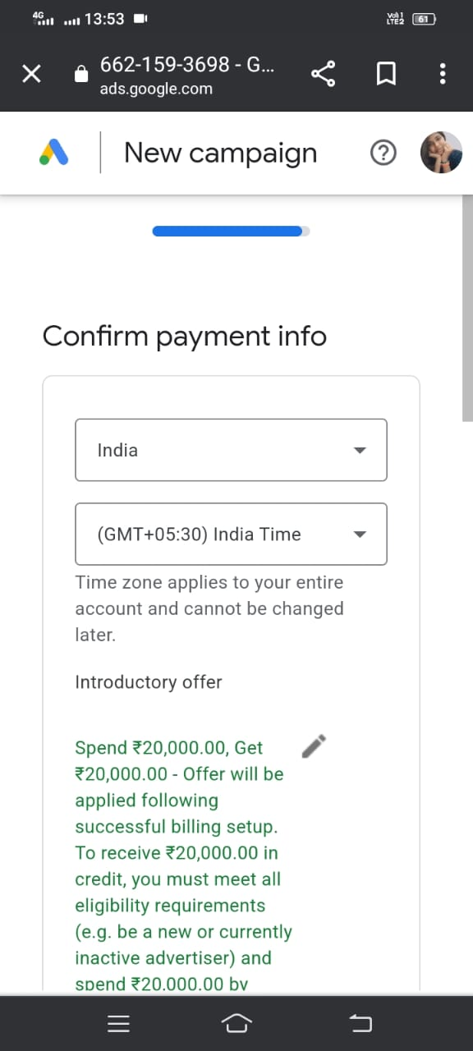

**STEP 14:**

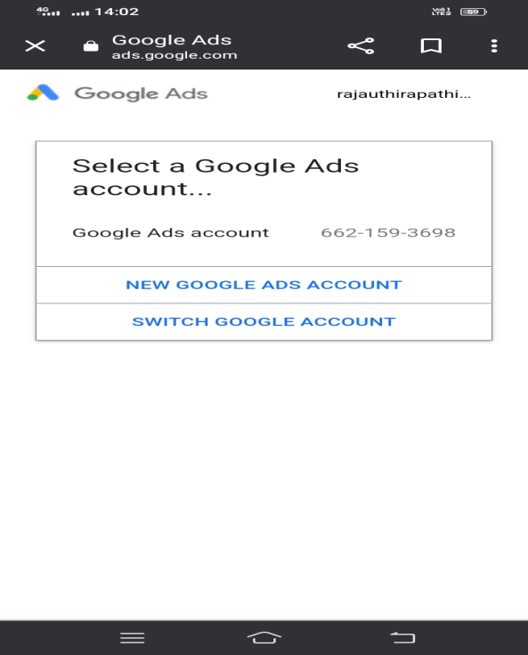

**STEP 15:**

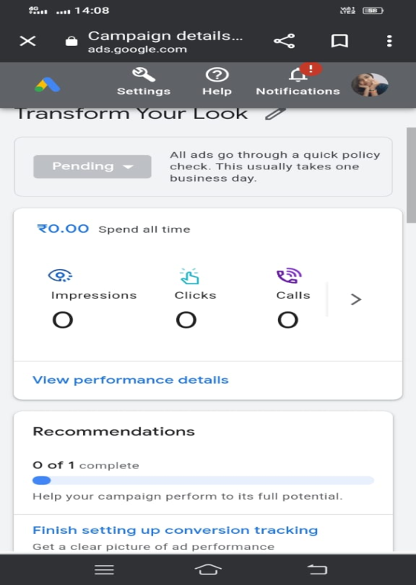

**OUR PROJECT LINK**

[**https://ads.google.com/aw/express/dashboard?ocid=1501619512&euid=1020550750&__u=1926336750&uscid=1501619512&__c=3570125688&authuser=0&campaignId=20729840551&workspaceId=0**](https://ads.google.com/aw/express/dashboard?ocid=1501619512&euid=1020550750&__u=1926336750&uscid=1501619512&__c=3570125688&authuser=0&campaignId=20729840551&workspaceId=0)